**Monday 10th January**

**Subject:** Reading

**Topic:** Word Recognition - The Flood (Rainbow Reader Page 144)

Read the story and underline the unfamiliar words, write them and the meanings in your note books.

**Subject: Grammar**

**Topic: Nouns -Singular and Plural**

Plural nouns are words used to indicate that there is more than one person, animal, place, thing, or idea.

Most singular nouns are made plural by simply putting an -s at the end. There are many different rules regarding pluralisation depending on what letter a noun ends in. Irregular nouns do not follow plural noun rules, so they must be memorized or looked up in the dictionary.

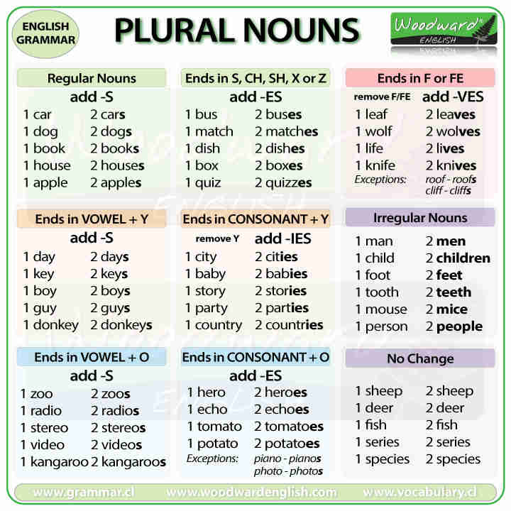

**Complete the table.**

|  |  |
| --- | --- |
| **Singular** | **Plural** |
| **Book** |  |
| **Fish** |  |
|  | **pianos** |
|  | **videos** |
| **Child** |  |
| **sheep** |  |
|  | **furniture** |

**Copy and complete in exercise book**

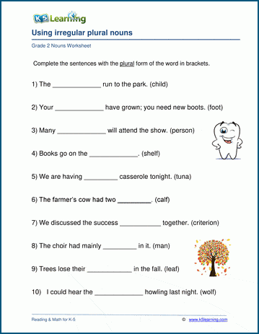

**Subject: Mathematics**

**Topic: Fraction**

**Activity: View the videos**

[**https://www.youtube.com/watch?v=N3__8MmaiLE**](https://www.youtube.com/watch?v=N3__8MmaiLE)

[**https://www.youtube.com/watch?v=hWQpXGNZSpY**](https://www.youtube.com/watch?v=hWQpXGNZSpY)

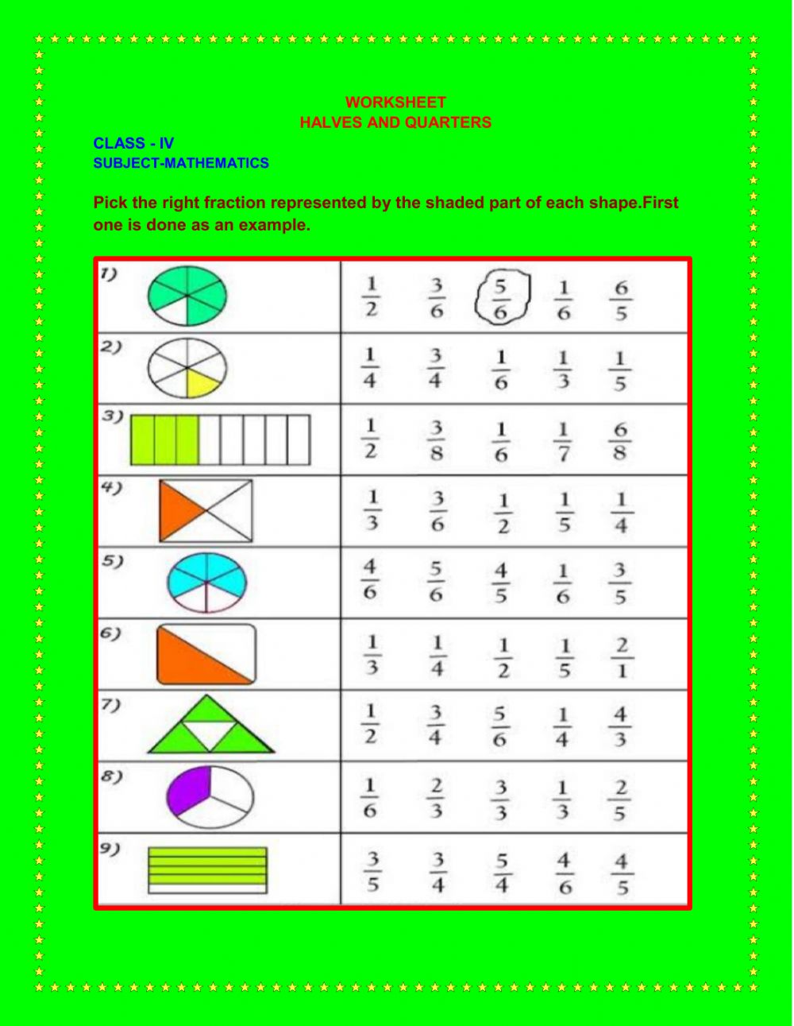

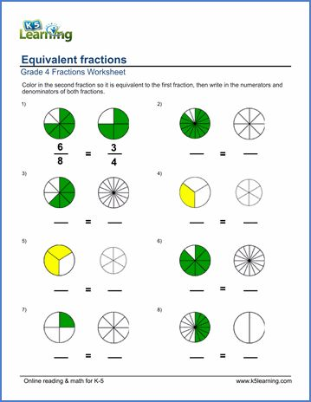

**Subject : Social Studies**

**Topic: Parishes**

**Use the map below to answer the following questions**

**Map of St. Kitts and Nevis**

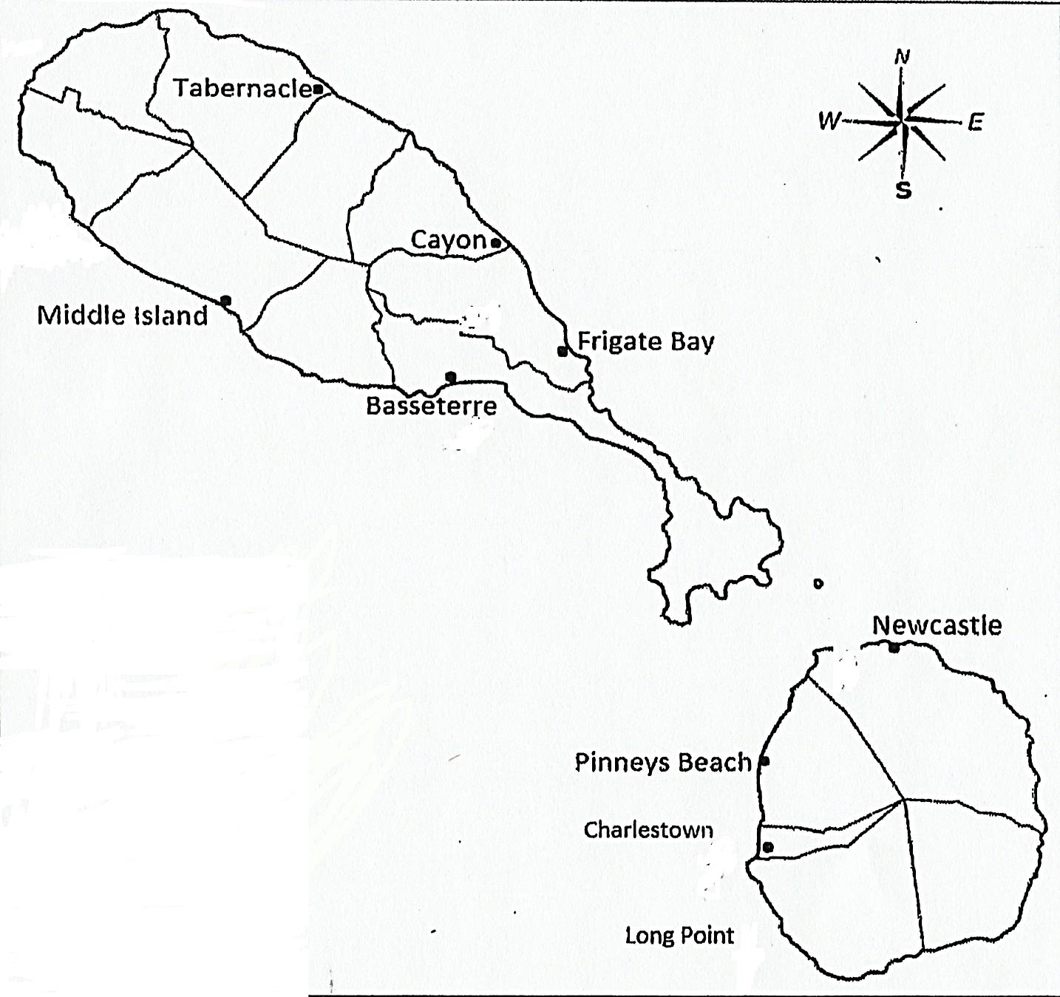

Key

Parish Boundary

* Settlements

1. **Place the letters GV in the parish where Green Valley is celebrated.**
2. **The Grade five (5) students wish to travel from Basseterre to Charlestown by boat, which direction will they travel?**

**________________________________________________________________________________________________________________________________**

1. **Put the letter N in the parish where Lord Nelson and Fanny Nisbett were married.**
2. **In which direction is St. Thomas Parish, St. Kitts from St. Ann Parish, St. Kitts?**

**________________________________________________________________________________________________________________________________**

1. **Put a circle around one of the areas where the French settled in St. Kitts.**